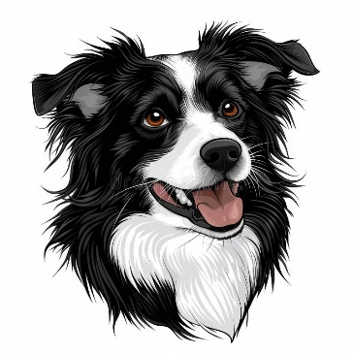
The Forgetful Farmer
In the highlands of Scotland, there lived a famer and his wife and their 4 children. 2 of their children had 2 children each and 2 of them had 1 child each. Can you work out how many people lived on their farm? (12)
Also living on the farm, was their 2 border collies. These were working sheep dogs and their job was to go off into the 9 fields, round up the sheep and take them wherever the farmer wanted them. The famers had to keep the sheep in separate fields. There were 26 sheep in each field. How many sheep did they have altogether? (234)
One morning, the farmer and 2 of his children went out in the field with the dogs, rounding up the sheep. When they got back to the farm they had 182 sheep in the barn. The farmer was very confused. Can you work out what has gone wrong? (They missed rounding up in 2 fields!)
After realising his mistake, the farmer went back out to the fields and rounded up the rest of the sheep with his dogs. Finally, he had all 234 sheep back in the barn.
The farmer’s last job of the day was to sort the sheep into their pens. He had 6 pens in total, so how many sheep will be in each pen if he shares them equally? (39)
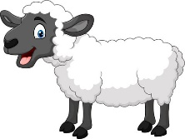

The Great Battle
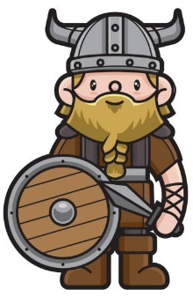
In the middle of England, there were 725 Vikings and 662 Anglo-Saxons battling each other. How many soldiers were there altogether? (1387)
If all the Vikings had 2 weapons and all of the Anglo-Saxons had 3 weapons, how many weapons were there on the battlefield? (3426)
At the end of the battle, 357 Vikings had died and 539 Anglo-Saxons had died. How many total weapons were left in the soldiers’ hands that were alive? (1105)

