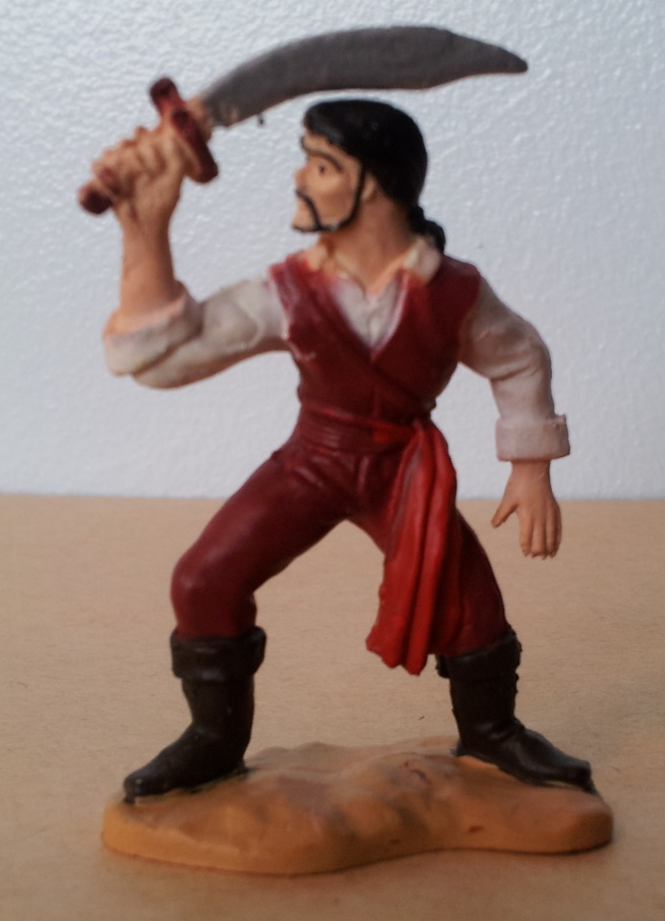
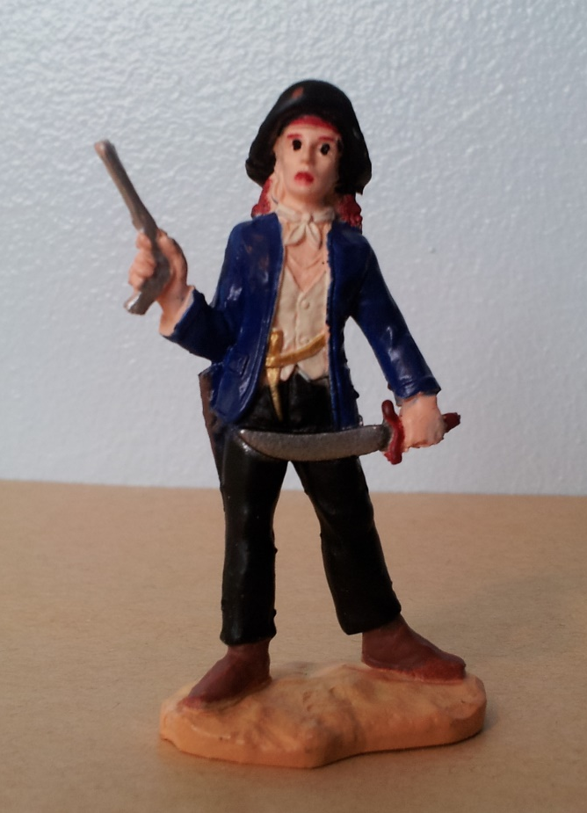
I can write a caption for the pirate. I must have a -
ABC capital letter and a
full stop
________________________
________________________
________________________
________________________
________________________
________________________
I can write a caption for the pirate. I must have a -
ABC capital letter and a full stop
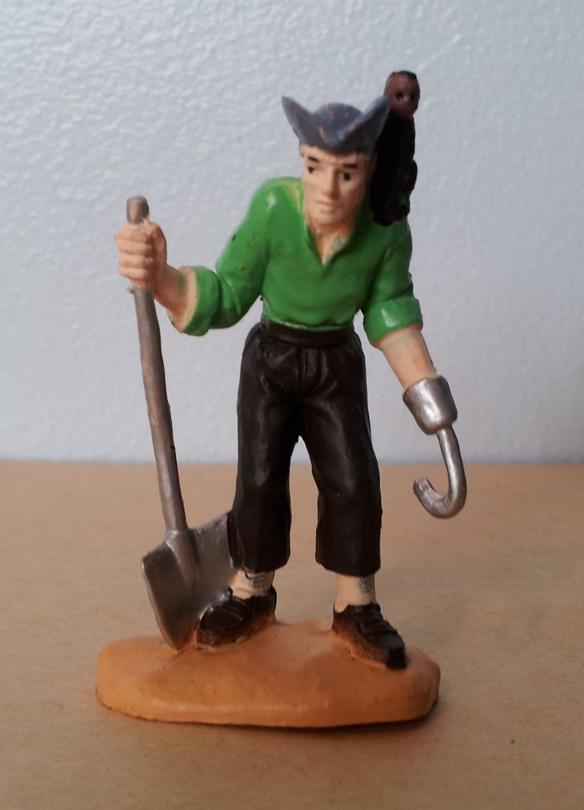
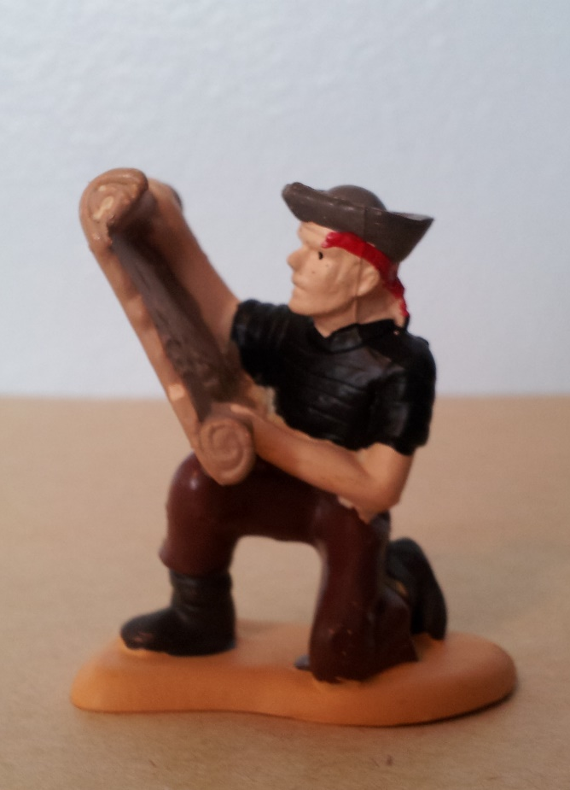
I can write a caption for the pirate.
I must have a –

ABC capital letter
and a full stop
________________________
________________________
________________________
I can write a caption for the pirate. I must have a -
ABC capital letter and a full stop
________________________
________________________
________________________

