has
sails

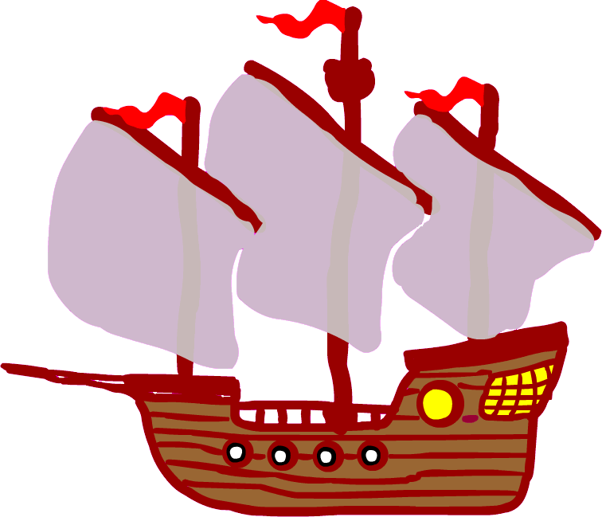
Cut or copy out the words and put in the right order.

portholes.
and
3
ship
The
4

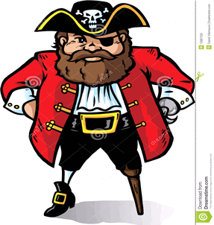

3

ship
Cut or copy out the words and put in the right order.

.
the
charge
is

of
captain
in
The

